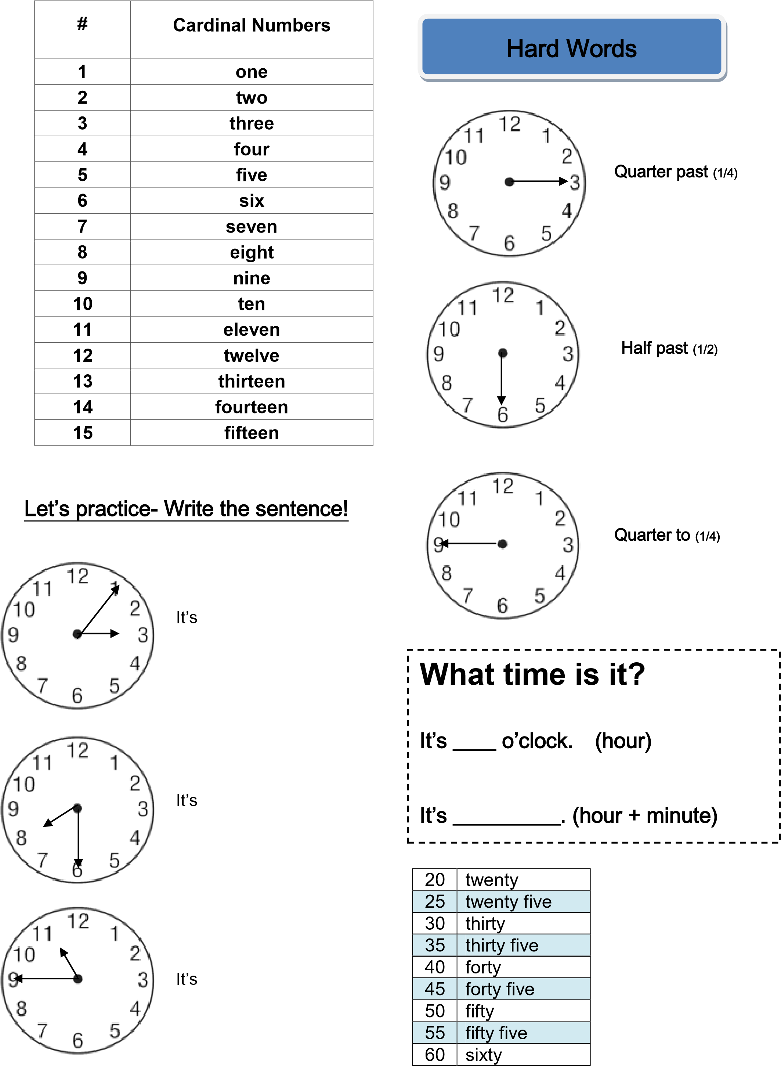Telling Time ~ Cheat Sheet Name _____________

3 and 6

11 and a quarter

7 and half

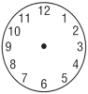

Hour

Minute